Liouville's theorem (complex analysis)

Intro

Statement

In complex analysis, Liouville theorem states that every bounded entire function must be constant. That is, every holomorphic function $$f$$ for which there exists a positive number $$M$$

such that $$\left|f\left(z\right)\right|<M$$ for all $$z$$ belongs to $$C$$.

Proof

Method 1:

With fact of holomorphic functions are analytics,

If $$f$$ is an entire function, it can be represented by Tylor series about 0.

$$f\left(z\right)$$ = $$sigma\left(a_{k}z^{k},k=0,k=\inf{}\right)$$

where

$$a_{k}$$ = $$\frac{f^{\left(k\right)}\left(0\right)}{k!}$$ = $$\frac{1}{2⋅pi\left(\right)⋅i}⋅integral\left(C_{r},\frac{f\left(l\right)}{l^{k+1}}dl\right)$$

And $$C_{r}$$ denotes the circle about 0 of radius $$r>0$$.

Suppose $$f$$ is bounded. We can estimate directly.

$$\left|a_{k}\right|$$

$$≤$$ $$\frac{1}{2⋅pi\left(\right)}⋅integral\left(C_{r},\frac{\left|f\left(l\right)\right|}{{\left|l\right|}^{k+1}}\left|dl\right|\right)$$

$$≤$$ $$\frac{1}{2⋅pi\left(\right)}⋅integral\left(C_{r},\frac{M}{r^{k+1}}\left|dl\right|\right)$$

= $$\frac{M}{2⋅pi\left(\right)⋅r^{k+1}}⋅integral\left(C_{r},\left|dl\right|\right)$$

= $$\frac{M}{2⋅pi\left(\right)⋅r^{k+1}}⋅2⋅pi\left(\right)⋅r$$

= $$\frac{M}{r^{k}}$$

Therefore, letting $$r$$ tends to inf, will gives one that $$a_{k}$$ = 0 for all $$k≥1$$. Thus,

$$f\left(z\right)$$ = $$a_{0}$$ = $$0$$ which completes the proof.

Method 2:

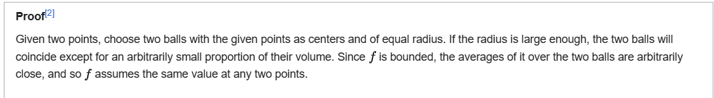

Ref

[Liouville's theorem (complex analysis) - Wikipedia](https://en.wikipedia.org/wiki/Liouville%27s_theorem_(complex_analysis))